Remote UAC prevents local administrative accounts from accessing ADMIN$ by preventing local admin accounts from running in an elevated mode from a network connection. To access ADMIN$ using a local account, Remote UAC will need to be disabled. *This in no way impacts regular GUI-based (userland) UAC*.

To disable Remote UAC, an entry will need to be made in the registry of the affected target computer:

Navigate to,

**HKEY_LOCAL_MACHINE\SOFTWARE\Microsoft\Windows\CurrentVersion\Policies\System**

Create a **DWORD** value called **LocalAccountTokenFilterPolicy** and assign it a value of **1**.

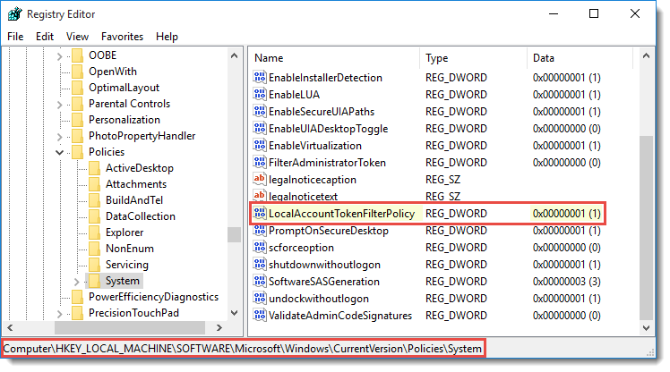

A reboot is recommended but not required, however, restarting the Server service is necessary.

**NOTES:**\* By default, when local credentials are used to access a Windows Vista (or later OS) system that is a member of a Windows Domain, this problem does not exist. Your Windows domain may still disable Remote UAC.  
* Remote administrative access is denied to local accounts when a Windows Vista (or later OS) is NOT a member of a Windows 2003 or later domain.